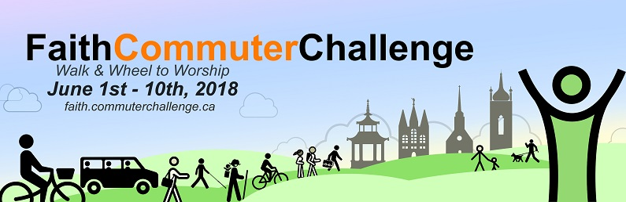

2018 COMMUNICATIONS KIT

Table of Contents
Background 2
Website Links 2
Press Release 3
Transportation Facts 4
Introductory PowerPoint Presentation 4
Bulletin and Newsletter Blurbs 5
Long Version for Newsletter 5
Short Version for Faith Community Bulletin 5
Social Media 6
Primary Hashtag 6
Twitter 6
Other Hashtags 6
Other Twitter Handles 6
Sample Tweets 6
Facebook 8
Sample Facebook Post 8
Graphics 10
Logos 10
Social Media Banners 11
Poster 12
Photos 13

Background
The Commuter Challenge is a Canada-wide program that has been running in workplaces for a number of years to encourage employees to leave their cars at home and celebrate active and sustainable modes of transportation for one week, coinciding with Canadian Environment Week.

Faith & the Common Good has partnered with the Commuter Challenge team to introduce the Faith Commuter Challenge. Transportation comprises more than 40% of an average faith community’s carbon footprint. For that reason, encouraging more sustainable modes of transportation can make a large change in the environmental sustainability of a faith community. Running this event as a challenge enables people to participate in a fun and engaging way while considering the impact of their ongoing behaviour.

The 2018 Faith Commuter Challenge takes place June 1-10, 2018. Faith & the Common Good is a national charity which supports diverse faith and spiritual communities contribute to greener, healthier, more resilient neighborhoods.

Website Links
Faith & the Common Good: http://www.faithcommongood.org/
Faith Commuter Challenge: http://www.faithcommongood.org/faith_commuter_challenge
and https://faith.commuterchallenge.ca/
Commuter Challenge: https://commuterchallenge.ca/

Press Release
National Faith Commuter Challenge, June 1-10: Interfaith ‘get to worship without your car’

Did you know that transportation comprises 40% of an average faith community’s carbon footprint? Transportation is the second largest source of Canada’s GHG emissions. That’s why traveling green is one of the most important ways we can be stewards of our planet.

This spring, Faith & the Common Good is working to make the faith sector a part of the nationwide Commuter Challenge that takes place in June, and coincides with National Environment Week. Faith communities will be encouraged to reduce the ecological footprint of commuting to their centres of worship.

Between June 1-10, people of all faiths are invited to pick a day and travel to worship on foot, by bike, or by public transit and carpooling. Participating faith groups will have a chance to win special recognition and take part in a nationwide, friendly, climate-action challenge.

On that day, participants will be able to log in to track their trips to worship and also see their GHG emission reduction, calorie consumption, distance, and fuel cost savings. They'll be able to check out which faith communities and cities have the highest percentage of participating travelers.

“We wanted to design a climate action program that would be fun and easy to participate in for congregations across the country.” says Executive Director, Lucy Cummings. “The website lets you see how leaving your car at home can save money, burn calories, and contribute to a healthy environment. When our diverse faith communities come together to fulfill their sacred calling to care for Creation like this, the impact can be powerful.”

Go that extra mile!

Individuals can register their faith group and themselves and log commuter distances through a new Faith Section of the Commuter Challenge website. Details can be found here: http://www.faithcommongood.org/faith_commuter_challenge

Not only will participating faith communities be reducing emissions and contributing to cleaner air while getting some fun exercise in, they’ll also be joining a network of other sustainable transportation supporters and fostering new friendships and connections.
In addition, during the Faith Commuter Challenge, why not encourage further activities in support of sustainable transportation such as:
- Launching a ride-share program or a “ride the bus together” program
- Hosting a bicycle tune-up station, distributing bike maps
- A special blessing ceremony, prayers, or acknowledgement of all the ways people are working to reduce their carbon footprint
- A neighbourhood bike ride before or after a worship service.

Transportation Facts

In 2015, the transportation sector was the second largest source of GHG emissions, accounting for 24% of total national emissions. Emissions from passenger vehicles alone accounted for almost 13% of total national emissions. (Source: Environment and Climate Change Canada: Greenhouse Gas Emissions by Canadian Economic Sector http://ec.gc.ca/indicateurs-indicators/default.asp?lang=en&n=F60DB708-1)

It takes 130 trees to produce the amount of oxygen needed to combat the climate-changing greenhouse gases (GHG) emitted from one car each year. (Source: United States Environmental Protection Agency: Greenhouse Gas Equivalencies Calculator https://www.epa.gov/energy/greenhouse-gas-equivalencies-calculator)

Introductory PowerPoint Presentation

An introductory presentation for your faith community can be found at http://www.faithcommongood.org/fcc_presentation

Bulletin and Newsletter Blurbs

Long Version for Newsletter

National Interfaith Commuter Challenge June 1- 10: Get To Worship A Greener Way

Transportation comprises more than 40% of an average faith community’s carbon footprint, so traveling green is one of the most important ways we can be stewards of our planet.

From June 1-10, 2018, Faith & the Common Good, along with partners across the country, invites your faith community to participate in the Faith Commuter Challenge (part of the National Commuter Challenge). Pick at least one day during the challenge week to leave your car at home. Join friends, family, and fellow congregants to travel to worship on foot, by bike, by public transit, or carpool. Do whatever moves you!
Your faith group will be part of a national challenge among faith groups across the country, for a chance to do our part to make our communities greener and healthier. Join us! It’s good for Creation, your community, and your health!

Register and log commuter distances through a new Faith Section of the Commuter Challenge website. Details found here: http://www.faithcommongood.org/faith_commuter_challenge. Sign up at faith.commuterchallenge.ca.

Be part of the fun while promoting active transportation!

Short Version for Faith Community Bulletin

From June 1-10, Faith & the Common Good invites us to take part in the Faith Commuter Challenge (part of the National Commuter Challenge). There are two weekends to choose from to pick a day for our faith community to participate. Join friends and family to travel to worship on foot, by bike, by public transit or carpool. Let’s take this step to tread more lightly on the earth! It would be great to have a coordinator to sign up our faith community. It’s easy and Faith & the Common Good can help. Contact [chapter coordinator] at [chapter coordinator contact info] or sign up directly at faith.commuterchallenge.ca.

OR

From June 1-10, Faith & the Common Good invite us to take part in the Faith Commuter Challenge (part of the National Commuter Challenge). Our faith community is registered to participate. Join friends and family to travel to worship on foot, by bike, by public transit or carpool. Let’s take this step to tread more lightly on the earth! Sign up at faith.commuterchallenge.ca.

Social Media

Primary Hashtag
#FCC2018

Twitter
Faith & the Common Good: @FaithCommonGood
Commuter Challenge: @CommuterChllng

Other Hashtags
#CommuterChallenge
#FaithCommuterChallenge
#Walk2WorshipChallenge
#ShareYrRide2Worship
#SpiritedMove
#WalkWheel2Worship
#activetransportation

Other Twitter Handles
@FossilFreeFaith
@EcologyAction
@reThinkGreen
@EnvHamilton
@BC_Commuter
@STRCanada (Share the Road)
@SmartCommute
@GOtransit
@Metrolinx
@CanadaWalks
@ONtransport
@WalkBikePlaces
@TransitAlly
@EMcMahonMPP
@WellbeingTO

Use regional hashtags to reach local audiences:
For example: #Vancouver, #BC, #Calgary, #Sudbury, #HamONT, #Northumberland, #Guelph, #Simcoe, #GrandRiver, #Toronto, #yyz, #Brantford, #Durham, #Niagara, #Ottawa, #Halifax

Sample Tweets
Effective tweets can include images from our Photos and Graphics sections below.

April 19 – May 15

Spring is here, so get your bikes in gear. #FCC2018 is June 1-10.
https://faith.commuterchallenge.ca

Dust off your walking shoes! #FCC2018 is June 1-10. Register your #faith group at
https://faith.commuterchallenge.ca

Looking 4 a fun n healthy way 2 show u care 4 creation? #FCC2018 June 1-10
http://bit.ly/2nLRTIY #HamOnt #CommuterChallenge ‏

Does yr place of worship have a bike rack? Get ready 4 the #FaithCommuterChallenge. #FCC2018 June 1-10 [add bike rack photo from Photos section]

#Halifax faith communities are gearing up for the #FCC2018. #WalkWheel2Worship @ecologyaction @CommuterChllng http://bit.ly/2nLRTIY

#Vancouver faith communities are gearing up for the #FCC2018. #WalkWheel2Worship @fossilfreefaith @CommuterChllng http://bit.ly/2nLRTIY

#Sudbury faith communities are gearing up for the #FCC2018. #WalkWheel2Worship @reThinkGreen @CommuterChllng http://bit.ly/2nLRTIY

#Hamilton faith communities are gearing up for the #FCC2018. #WalkWheel2Worship @EnvHamilton @CommuterChllng http://bit.ly/2nLRTIY

#FCC2018 Sign up n log green trips at https://faith.commuterchallenge.ca! @CommuterChllng ‏

#Faith groups walk, wheel, share rides to worship June 1-10. #FCC2018
http://bit.ly/2qWaGUI @CommuterChllng ‏

Hey, faith groups! Join us 2 curb yr carbon emissions. June 1-10 #FCC2018 @commuterchllng http://bit.ly/2qWaGUI [add traffic jam photo from Photos section]

#ShareYrRide2Worship #WalkWheel2Worship Do what moves u. #FCC2018 #interfaith @commuterchllng http://bit.ly/2qWaGUI

Give yr car a day off! #WalkWheel2Worship #FCC2018 #interfaith @commuterchllng http://bit.ly/2qWaGUI [add dog photo from Photos section]

June 1-10 Join #faith communities for a greener way to worship #FCC2018 #activetransportation http://bit.ly/2qWaGUI

#FCC2018 Join the #FaithCommuterChallenge for sustainable, active transportation. http://bit.ly/2qWaGUI

Ditch the car! Take the #FCC2018 and curb emissions. #CommuterChallenge
https://faith.commuterchallenge.ca

#interfaith Walk, Roll, Wheel or Share your Ride to worship. June 1-10. #FCC2018 http://bit.ly/2qWaGUI
@CommuterChllng ‏

#FCC2018 June 1- 10 Get to #worship without your car https://faith.commuterchallenge.ca
@CommuterChllng ‏

#FCC2018 Curbing commuter impacts through a friendly competition between #faith communities @CommuterChllng https://faith.commuterchallenge.ca

#FCC2018 Improve air quality with eco-friendly commuting to #worship. Fun n healthy! #hamOnt @CommuterChllng ‏ https://faith.commuterchallenge.ca

May 15 – June 1

Congrats xxxxxxxxx 4 joining the #FaithCommuterChallenge. Excited to see what moves u! #FCC2018 #[location]

During June 1-10
Tweet us a photo of your #faith community getting to worship without a car.
@CommuterChllng #FCC2018

#FCC2018 XXX faith communities logged XXXX green commute trips!!!! Join them at https://faith.commuterchallenge.ca @CommuterChllng ‏

Facebook

Faith & the Common Good page: https://www.facebook.com/FaithCommonGood/
Regional Facebook pages:
Vancouver: https://www.facebook.com/salalandcedar
Sudbury: https://www.facebook.com/reThinkGreenGreaterSudbury/
Hamilton: https://www.facebook.com/EnvHamilton/
Halifax: https://www.facebook.com/EcologyActionCentre/

Sample Facebook Post

For our [Regional Hashtag] friends!

National Interfaith Commuter Challenge June 1- 10: Get To Worship A Greener Way.
From June 1-10, Faith & the Common Good invites your faith community to participate in the Faith Commuter Challenge (as part of the National Commuter Challenge) and travel to worship on foot, by bike, by public transit or carpool.
Your faith group will be joining other faith groups across the country to care for Creation! Find details here: http://bit.ly/2nx9SSF Be part of the fun while promoting active transportation!

Graphics

Logos

National organizer logo:

Project logos:
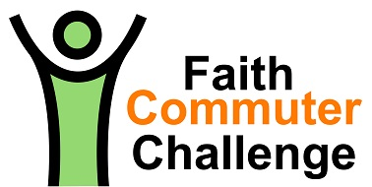

Social Media Banners

Project banners:

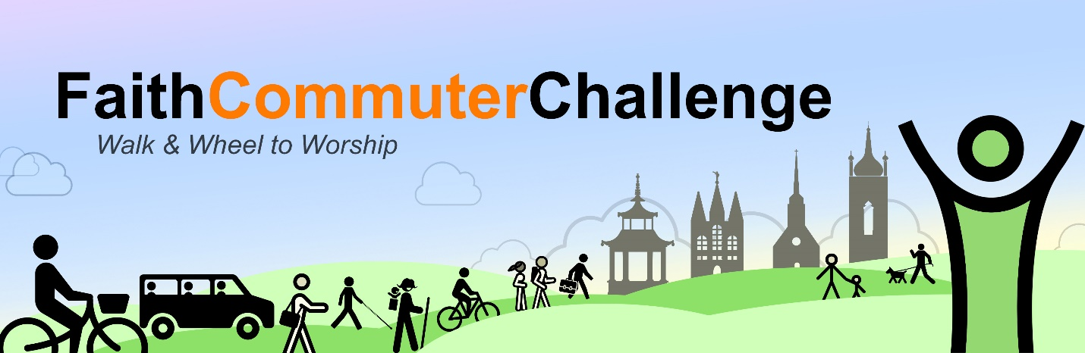

Poster

Project poster:
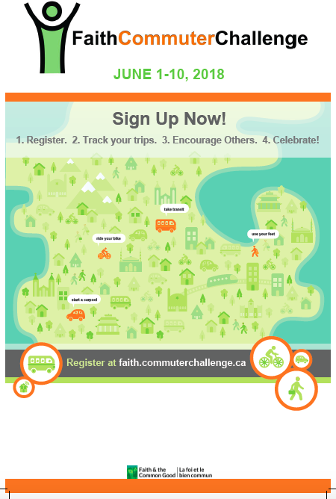

This generic poster is also available as a printable PDF at http://www.faithcommongood.org/faith_commuter_challenge

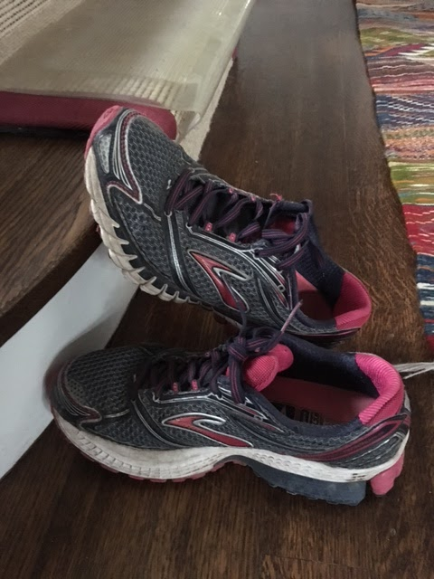
Photos
